Outline:-
Attendance Management System essentially has two primary modules for legitimate working
•First module is administrator which has appropriate for making space for new bunch. Any passage of new workforce, Updating in subject if fundamental, and sending notice.
•Second module is dealt with by the client which can be a flawed or an administrator. Client has a privilege of making day by day participation, creating report.
Design & implementation of database:- Database would be as follows in terms of tables.
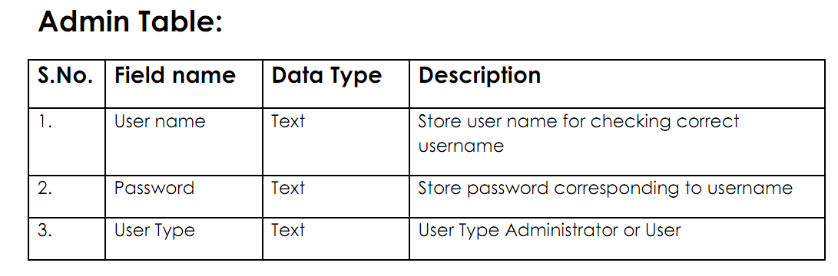
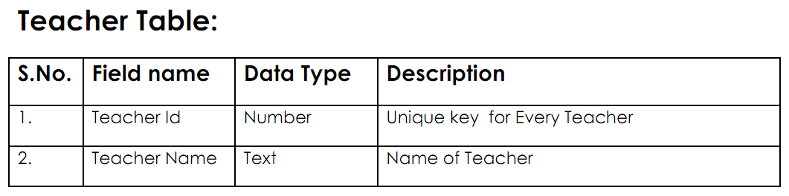
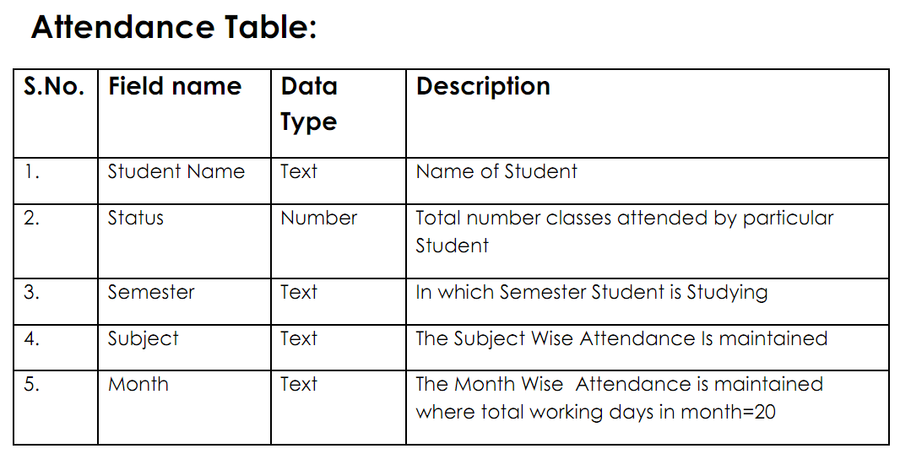
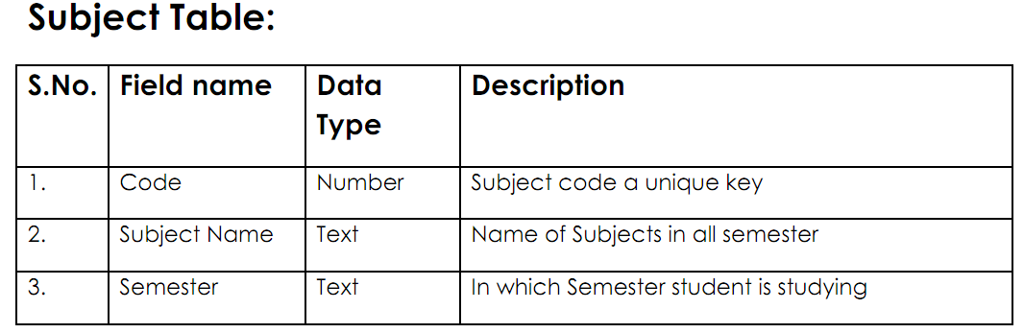
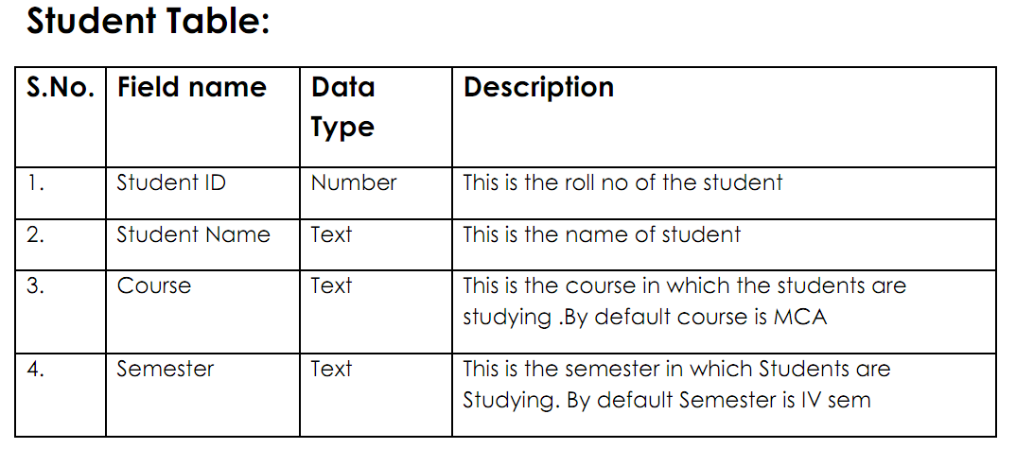

- What is the business need and business problem?
In any college there is a participation enroll for every one of the understudies where the workforce take the participation of every understudy each hour. After some time, for example, following one month the staff need to check the quantity of days during the time for each understudy display. So there is business requirement for the college to get the participation of understudies utilizing PC framework that uses the database.
Attendance Management System is a product created for every day understudy participation in schools, arrangements and establishments. It encourages to get to the participation data of a specific understudy in a specific class. The data is sorted by the administrators, which will be given by the instructor to a specific class. This framework will likewise help in assessing participation qualification criteria of an understudy.
• What is the purpose of the project?
The purpose behind creating Attendance Management System is to mechanize the convention method for taking participation. Another reason for building up this product is to create the report consequently toward the finish of the session or in the between of the session.
• What is the scope of the work?
The scope of the venture is the framework on which the product is introduced, i.e. the venture is created as a desktop application, and it will work for a specific establishment. Be that as it may, later on the venture can be adjusted to work it on the web.
• What will be achieved by implementing this database?
Reports are effectively produced: reports can be effortlessly created in the proposed framework so client can produce the report according to the necessity (month to month) or amidst the session. Client can give the notice to the understudies so he/she end up noticeably customary.
PC administrator control will be there so no way of mistakes. Also putting away and recovering of data is simple. So work should be possible rapidly and in time.
• What benefits does the new database offer?
With the assistance of new database participation can be taken in two ways:
1. On the premise of Subject and month.
2. On the premise of Class

ER Diagram:
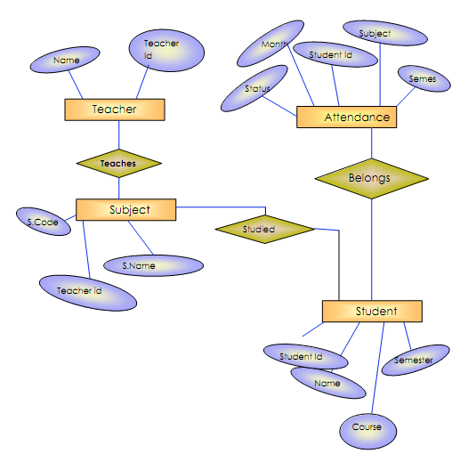

Business Rules
- Teacher teaches one or many Subjects.
- A subject is taught by only one teacher.
- A student studies one or more subjects.
- A subject is studied by one or more students.
- A student has one or more attendances.
- An attendance is of only one student.
- A student is enrolled to only one enrollment.
- An enrollment is for only one student.

ER Diagram

